Standard Operating Procedure for Using Formaldehyde
in the PI Name Lab (Bldg#, Room#)

Print a copy and keep with your lab’s training documents.
Department
Principal Investigator (PI)
PI Phone Number
Lab Manager/Secondary Contact
Lab Manager Phone Number
Emergency/24-Hour Contact
Emergency Contact Phone Number

- Purpose
The purpose of this document is to provide the information necessary to safely use formaldehyde in the PI Name Laboratory and to comply with the OSHA Formaldehyde Standard (29 CFR – 1910.1048).
- Hazard Identification
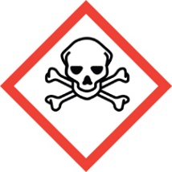 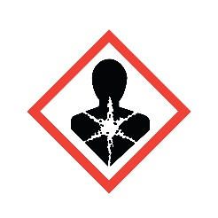 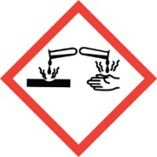 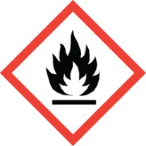
The hazards of formaldehyde are listed below:
- Carcinogenic –
Formaldehyde is a Group 1 Carcinogen, meaning it is known to cause cancer in humans.
- Corrosive & Irritant –
Formaldehyde is an upper respiratory tract and eye irritant. It is highly volatile and inhalation is a major route of exposure. The odor threshold is 1 part per million (ppm) in air. Concentrations greater than 0.1 ppm (in air) can irritate the nose, throat and lungs. Therefore, lack of odor cannot be used as an indicator of safe use of formaldehyde. Concentrations greater than 25 ppm can cause severe injury, including pulmonary edema (water in the lungs). Contact with the skin can cause mild to severe irritation that can worsen with increased exposures (sensitivity). Contact with eyes will cause damage to the eyes.
- Flammable –
Concentrated solutions of formaldehyde are flammable. Weaker solutions can be combustible.
- Training Requirements
All UNM personnel who use formaldehyde must be trained before using it. Trainings must include:
- This SOP (read and sign)
- Formaldehyde Safety (on Learning Central)
- Engineering & Administrative Controls
Formaldehyde must only be used within a properly functioning chemical fume hood that has a current annual certification. (Engineering Control).
All lab personnel who use formaldehyde must be trained on the hazards of formaldehyde, including being familiar with this SOP (Administrative Control).
The door to the PI Name Lab is posted with signage indicating the presence of and hazards associated with formaldehyde (Administrative Control).

- Required Personal Protective Equipment (PPE)
- Hand Protection: Nitrile, neoprene, natural rubber or PVC gloves must be used when handling containers of formaldehyde and while working with formaldehyde.

- Skin and Body Protection: A lab coat must be worn when handling containers of formaldehyde and while working with formaldehyde.

- Eye Protection: Always wear safety glasses or goggles when handling containers of formaldehyde and while working with formaldehyde.

- Respiratory Protection: Always open, pour, handle, and use formaldehyde within a properly functioning fume hood. Additional respiratory protection is not required.
- Standard Operating Procedures for Handling Formaldehyde in the PI Name Lab
  - Put on proper PPE (glasses, gloves, lab coat).
  - Remove formaldehyde container from the flammables cabinet and place it in the fume hood.
  - Continue listing the steps of the procedure in which ethidium bromide is used in this lab (i.e. how to weigh material, quantity used, etc.)
  - Place the container of formaldehyde back in the flammables cabinet.
  - After removing gloves, wash hands thoroughly.
- Spill Procedures
For small/minor spills (<1L), use the materials in your lab’s spill kit to clean up a formaldehyde spill. Minimum PPE for cleaning up a spill is safety glasses/goggles, gloves and lab coat. The spill clean-up materials must be double-bagged, tightly closed, labeled and picked up by EHS for disposal.
Spills in excess of 1L of formaldehyde should not be cleaned up by lab personnel. In the event of a large/major spill of formaldehyde, evacuate the area and call:
- UNM Police -- 911 or 505-277-2241, and
- Environmental Health & Safety (EHS) – 505-277-2753 during business hours, or
- EHS Duty Officer Pager (after hours) -- 505-951-0194 (enter your phone number after the message)
- First Aid Procedures
In the event of a formaldehyde exposure:
- Skin or eye contact - wash immediately in safety shower or eyewash for 15 minutes, then seek medical attention.
- If the exposure is severe, seek medical attention at the emergency room.
  - If heading to UNMH, a non-injured person should contact the UNMH Charge Nurse in advance at 505-604-9349 and inform them of the situation.
- UNM employees should contact Employee Occupational Health Services (EOHS) at 505-272-8034.
- UNM students should contact Student Health Services at 505-277-7810.
- If the exposure occurs after hours, employees and students should seek medical treatment at an emergency room.
- The supervisor of the injured person and EHS must be notified as soon as possible after the exposure.
- A notice of Accident, Incident, or Spill form should be filled out on the EHS website (https://ehs.unm.edu/accident-incident-spill-reporting/index.html)
- Disposal Procedures
Formaldehyde and formaldehyde-containing waste should be collected in a suitable container (plastic or glass is acceptable) and properly labeled as soon as waste is added to the container. Formaldehyde waste should be labeled as such:
HAZARDOUS WASTE
Formaldehyde (include concentration)
Toxic & Flammable
Call EHS at 505-277-2753 to schedule a pickup of formaldehyde waste and/or other chemical waste.

- Other Emergencies
- Fire or Medical Emergency -- 911 or 505-277-2241 (UNM Police)
- Life-Threatening Emergency, After Hours, Weekends and Holidays – 911
  - EHS After Hours Duty Officer Pager – 505-951-0194 (enter return phone # after the outgoing message)
- Non-Life-Threatening Emergency – Call EHS at 505-277-2753 for assistance and/or to report the incident.

Principal Investigator SOP Approval
By signing and dating here, the Principal Investigator (PI Name) certifies that this SOP for Formaldehyde is accurate and provides information sufficient to safely use formaldehyde in the PI Name Laboratory (Bldg#, Room#).
______________________________________________________________________________
Signature Printed Name/Title Date

I have read and understand the content of this SOP:
Name | Signature | Date

