Standard Operating Procedure for Using Hydrazine
in the (PI Name) Lab (Bldg#, Room#)

Print a copy and keep with your lab’s training documents.
Department
Principal Investigator (PI)
PI Phone #
Lab Manager
Lab Manager Phone #
Emergency Contact
Emergency Contact Phone #

- Purpose
The purpose of this document is to provide the information necessary to safely use hydrazine in the HESS Laboratories and to comply with OSHA requirements for working with hydrazine (CFR 1910.100 Table Z-1 for CAS No. 302-01-2).
- Hazards of Hydrazine
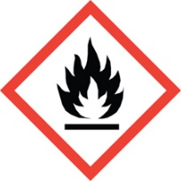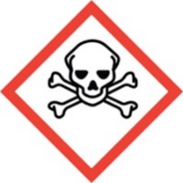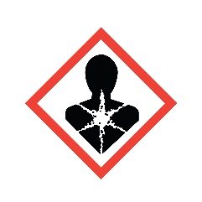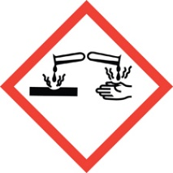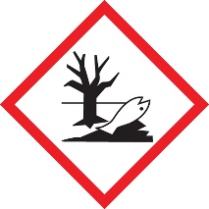
Flammable & Reactive -- Highly flammable, very reactive and unstable – used as a rocket propellent. Reacts with air, moisture, light, heat and friction. May ignite spontaneously if absorbed onto porous materials such as earth, asbestos, cloth or wood. May ignite spontaneously if mixed with hydrogen peroxide, nitric acid and nitrous oxide. Reacts explosively with potassium and sodium dichromate.
Acutely Toxic & Carcinogenic– Fatal if inhaled. Suspected human carcinogen. Chronic/long-term exposure may cause pneumonia, liver and kidney damage.
Symptoms of exposure may include severe eye, nose and throat irritation, facial numbness, facial swelling, increased salivation, headache, twitching, seizures, convulsions, coma. Gastrointestinal symptoms may include anorexia, nausea, vomiting. Pulmonary edema and hypotension (low blood pressure) are common. Toxic to the liver, ruptures red blood cells and may cause kidney and central nervous system damage. It is corrosive and causes severe damage to the skin and eyes upon contact. It is also a carcinogen, a sensitizer, and a reproductive toxin. Both acute and chronic exposure should absolutely be avoided.
Corrosive– Causes severe damage to skin and eyes upon contact.
- Incompatible With:

- Oxidizers
- Hydrogen peroxide
- Nitric acid
- Metal oxides
- Strong acids

- Training Requirements
All UNM personnel who use hydrazine must be trained on the hazards and how to protect themselves from the hazards before using it. Training must include:
- This SOP (read and sign)
- Engineering & Administrative Controls
Hydrazine must only be handled/used within the chemical fume hood, which is designed to pull air and fumes up and away from the user (Engineering Control).
All lab personnel who use hydrazine must be trained on the hazards of hydrazine, including being familiar with this SOP (Administrative Control).
The door to the (PI Name) Lab is posted with signage indicating the presence and hazards associated with hydrazine (Administrative Control).

- Required Personal Protective Equipment (PPE)
- Hand Protection: At a minimum, complete protection of the skin is essential. Nitrile or other chemical-protective gloves must be worn when handling hydrazine.

- Eye Protection: Complete eye protection – splash-proof glasses or goggles – must be worn when mixing and handling hydrazine and solutions of hydrazine. A facie shield is recommended if there is a high potential for splashing.

- Skin and Body Protection: A lab coat must be worn when handling hydrazine.

- Respiratory Protection: Always open, pour, mix, handle and use hydrazine within a properly functioning fume hood.
- Standard Operating Procedures for Using Hydrazine in the (PI Name) Lab:
  - Put on proper PPE (eye protection, gloves, lab coat)
  - Remove hydrazine container from storage location and place in fume hood.
  - Continue listing the steps for the procedure in which hydrazine is used in this lab (i.e. how to weigh material, quantity used, etc.)
  - Place the container back in its storage location.
  - After removing gloves, wash hands thoroughly.
- Spill Procedures
Do not attempt to clean up a spill of hydrazine. In the event of a spill, evacuate the area and call:
- UNM Police -- 911 or 505-277-2241, and
- Environmental Health & Safety (EHS) – 505-277-2753 (during business hours)
- EHS Duty Officer (after hours) – 505-951-0194 (enter your phone number after the message)
- First Aid Procedures
In the event of a hydrazine exposure, seek immediate medical attention.
- If heading to UNMH Emergency Room, contact the Charge Nurse in advance and inform of the situation.
  - UNMH Charge Nurse – 505-604-9349
  - Bring a Safety Data Sheet if possible
- UNM employees should contact Employee Occupational Health Services (EOHS) at 505-272-8034.
- UNM students should contact Student Health Services at 505-277-7810.
- If the exposure occurs after hours, employees and students should seek medical treatment at a hospital emergency room.
- The supervisor of the injured person and EHS must be notified as soon as possible after the exposure.
- A notice of Accident, Incident, or Spill form should be filled out on the EHS website (https://ehs.unm.edu/accident-incident-spill-reporting/index.html)

- Disposal Procedures
All chemical waste must be disposed of according to federal and state regulations and UNM's Chemical Hygiene Plan. Hydrazine and hydrazine-containing wastes should be placed in a suitable container and properly labeled as soon as waste is added to the container. Hydrazine waste should be labeled as such:
HAZARDOUS WASTE
Hydrazine (include quantity or concentration)
Flammable, Toxic, Corrosive, Reactive
Call EHS at 505-277-2753 to schedule a pickup of waste hydrazine and/or other chemical wastes.

- Other Emergencies
Fire or Medical Emergency -- Dial 911
Life-Threatening Emergency, After Hours, Weekends and Holidays – Dial 911
Non-Life-Threatening Emergency – Call EHS at 505-277-2753 to seek assistance and report the incident.
Principal Investigator SOP Approval
By signing and dating here, the Principal Investigator, (PI Name), certifies that this Standard Operating Procedure (SOP) for Using Hydrazine is accurate and provides information sufficient to safely use Hydrazine in the (PI Name) Laboratory (Bldg.#, Room #).
______________________________________________________________________
Signature Printed Name/Title Date

I have read and understand the content of this SOP:
Name | Signature | Date

